Safe Work Method Statement (SWMS)

SWMS Ref No: |  | Version | 1 | Issue date | [enter date] | Review Date | [enter date]

Location: [enter site name and address] | Date: [enter date]
Job / Task Description: [Event Name]
How to Complete the Risk Assessment template –
Step 1. Complete all relevant highlighted fields on page 1 and 2 to outline the event details, any applicable accreditations and any equipment used for the event
Step 2. Review the prepopulated Activities, Hazards/Risks and Control Measures and Actions from page 3. Delete and remove any that are not applicable to your event and add in any additional controls that you are implementing that are specific to your event.
Step 3. In the highlighted rows on page 23, add in any additional Activities, Hazards/Risks and Control Measures that are applicable to your event that have not been mentioned in the prepopulated template
Step 4. Using the risk matrix on page 25, select the likelihood, consequence and risk for each activity before and after your control measures are implemented. For example, when completed it should look like –
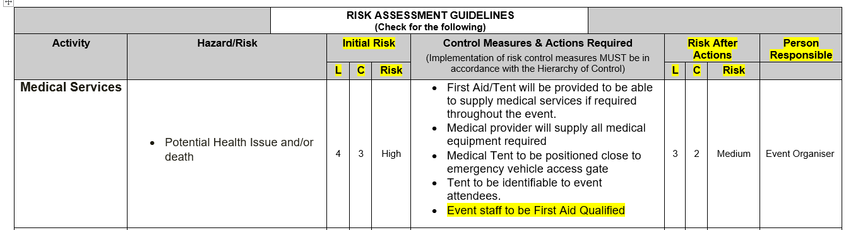

Training Required to Complete the Activity: |  | This SWMS has been produced to comply with the following Codes of Practice, Legislation, Australian Standards and Guides:
1. List training accreditation required eg traffic Control, Confined Space, First Aid,  - Insert relevant accreditations if applicable | 2. Training details are attached:  ☐ Yes  ☐ No  ☐ N/A | - AS 3745: Planning for emergencies in facilities  - Violence in the Workplace Guide 2002 – Workcover NSW  - Building Code of Australia.  - Managing the Risk of Hazardous Chemicals Code of Practice- July 2012’  - Work Health and Safety Regulation 2017: Chapter 3 General risk and workplace management  - Code of Practice: Managing the work environment and facilities  - Code of Practice: First Aid in the Workplace
List Plant/Equipment/Tools required for the Activity: | List Personal Protective Equipment (PPE) for the Activity: | List Equipment Maintenance Checks required for this Activity: e.g. daily inspection checklists, lifting slings, SWL, etc | Engineering Certificates /Permits/ Approvals required for this Activity e.g. demolition licences, road closure, hot works, confined spaces etc
- Insert details of equipment/tools used in event |  | Type: annual check of equipment | Ref/Doc:
Person Involved in the production and completing the Safe Work Method Statement (SWMS): |  | Potential for Environmental Harm
Insert Name |  | Air Noise Water Soil Flora & Fauna Heritage  Choose an item. Choose an item. Choose an item. Choose an item. Choose an item. Choose an item.  *Please select YES or NO for each category- If selecting YES also fill box Red
Person(s) Responsible for Supervising/ Inspecting Work:

Person(s) responsible for supervising the work, inspecting and approving work areas, safe work method statements, SWAT's, protective measures, plant/ equipment & power tools:

Name: Position: Signature:
Name: Position: Signature:

RISK ASSESSMENT GUIDELINES
(Check for the following)
Activity | Hazard/Risk |  | Initial Risk |  |  | Control Measures & Actions Required  (Implementation of risk control measures MUST be in accordance with the Hierarchy of Control) |  | Risk After Actions |  |  | Person Responsible
 |  |  | L | C | Risk |  |  | L | C | Risk
Permanent & portable structures | Potential injury |  |  |  |  | - All stallholders are to supply their own marquee and obtain their own public liability insurance. A list of these details is recorded by the event organiser  - All marquees to be securely weighted with a minimum of 80kg per marquee to their legs.  - This will be checked by event staff to ensure all stalls are secured correctly.  - A site inspection of permanent fixtures (stage, BBQ areas, and electrical outlets) will be undertaken by Council.  - Any temporary structures will be installed by licensed site crew  - Liaise with Council staff member about location of underground services before installing and pegs into the ground
Medical Services | - Potential Health Issue and/or death |  |  |  |  | - First Aid/Tent will be provided to be able to supply medical services if required throughout the event.  - Medical provider will supply all medical equipment required  - Medical Tent to be positioned close to emergency vehicle access gate  - Tent to be identifiable to event attendees.
COVID-19 Management | - Transferring COVID-19 |  |  |  |  | - Completing a NSW COVID-19 Safe Plan  - Implementing a NSW COVID-19 Safe Plan  - Adhering to current NSW Government Public Health Orders  - Provide hand sanitiser and equipment cleaned with alcohol solution  - Enforce 1.5m social distancing
Natural Disasters/  Weather | - Potential injury  i.e. High Winds, Storms, Fires etc |  |  |  |  | - A site inspection with appropriate Council staff will be undertaken to ensure trees are safe and permanent fixtures sound.  - Event organiser to notify all event attendees of event cancellation via social media due to severe weather.  - Any other natural disasters to be managed by Police, SES, Fire Brigade, Council After Hours Service.  - Obtain regular weather reports from the Bureau of Meteorology at RAAF Williamtown  - Monitor NSW Rural Fire Service and cancel event if high risk to surrounding residents.
 | - Sun Exposure |  |  |  |  | - Covered stage, stalls & activities in shade where possible, hydration, sunscreen, sun protective clothing, some shade shelters made available to the public.
Stallholders | - Potential Injury to patrons through trip hazards, stallholders displays and structures |  |  |  |  | - All stallholders are to supply their own marquee and obtain their own public liability insurance. A list of these details is recorded by the event organiser.  - All marquees to be securely weighted with sandbags only and placed in clearly marked areas  - This will be checked by event staff to ensure all stalls are secured correctly.  - All stallholders must have current Public Liability Insurance  - All food stalls must comply with Food Safe regulations and have a permit from PSC  - All generators or compressors used must be fuelled prior to coming on site  - If refuelling is necessary – it must be done in an isolated area well clear of public and not on grassed area.  - Safe refuelling procedures to be used to ensure the public and environment are protected.
Food Vendors | - Accessing the site whilst the public area in the area  - Potential illness  - Possible loss of power supply to run cooking and food storage units on food vans |  |  |  |  | - All stallholders are given a single access point where they are met with Council staff. The stallholders is to turn their hazard lights on whilst they are walked in by a staff member and guided into their position.  - Council staff are to direct public of the vehicle accessing the site and clear a path for the stallholders to access whilst managing public safety.  - Food to be stored in appropriate and correct environment. Comply with Food Safety Standards and have the relevant mobile food vendor approvals required.  - All stallholders to ensure that food handling and hygiene procedures are followed at all times.  - Food notification number obtained from all stall holders  - All stallholders to provide a copy of their Public Liability Insurance of at least $20million  - Council to oversee the setup and operation of all stalls over the duration of event.  - All stallholders to supply their own generators and allow for backs on standby and alternative water source.
Slips, Falls, trips | - Potential Injury |  |  |  |  | - Event staff to maintain and to undertake a site inspection prior to event setup  - Event Organiser to report customer complaints and potentially dangerous situations i.e. surface damage to action if required during event.  - All stallholders that are accessing power will have their leads strung airily or taped down to avoid any trip hazards  - Complete an incident report for any incidents and report to Council
Amenities | - Inadequate toilets available for event |  |  |  |  | - Additional portable toilets are provided for the event including an accessible toilet if required.  - Portable toilets will be checked throughout the event by Event Staff/Contractors to ensure they are clean and there are no issues.  - Portable toilets to be collected the following day to prevent vandalism and/or any inappropriate behaviour within toilets unsupervised.
Terrorism | - Potential Injury from a terrorist attack in any form |  |  |  |  | - Any incident to be reported directly to 000  - Event staff will be responsible for evacuating the event to the Emergency Evacuation Point with the assistance of the Police. All staff will be briefed prior to the event on emergency procedures.  - Advise Police of this event.  - Any Traffic plans to be developed, endorsed and approved by accredited personnel and Council.
Consigning | - Fatigue  - Speeding  - Non-conformance with legislative requirements |  |  |  |  | - When ordering ensure adequate time is allowed for delivery – do not enforce unrealistic time frames with suppliers and couriers |  |  |  |  | Site Controller  Consignor
Receiving, Loading and Unloading Heavy Vehicles (internal and external deliveries and pickup) | - Interaction with pedestrians and other vehicles |  |  |  |  | - Event Organiser is to assess the risks and direct the delivery or pickup vehicle to a safe area to unload or load  - Ensure loading and unloading areas do not encroach on vehicle or pedestrian travel paths. Where this is not possible ensure appropriate traffic control is employed (TCP, signage, traffic control personnel, etc.)  - Employ spotters when moving in close proximity to buildings, pedestrians or other plant.  - Ensure work area is clear of non-essential personnel |  |  |  |  | Site Controller  Loader  Unloader
 | - Driver unfit for work – Fatigued, inebriated, etc. |  |  |  |  | - Assess vehicle operator visually. If driver appears unfit to drive do not load vehicle. Within reason attempt to prevent driver from leaving premise.  - If driver become difficult or threatening do not put yourself or others at risk of harm.  - Allow driver to leave and alert police (provide vehicle and driver description, including registration number and vehicle company/owner and last known location/direction)  - Notify vehicle company if applicable |  |  |  |  | Site Controller  Loader  Unloader
 | - Vehicle not fit for purpose |  |  |  |  | - Ensure vehicle is appropriate for the load being picked up  - If a safety issue is observed on the vehicle it is to be reported to the driver. If it is a critical safety issue (e.g. heavy oil leaks, damaged tyre, etc.) the driver is to be instructed to park up and not leave the area. The fault is to be reported to their head office and arrangements made to repair to vehicle on site or organise safe removal  - If driver refuses to comply report to police and vehicle owner |  |  |  |  | Site Controller  Loader  Unloader
 | - Overloaded or Uneven Loaded Vehicle |  |  |  |  | - Ensure weight and dimensions of intended load is known prior to pick up vehicle arriving  - Ensure pickup vehicle and/or trailer is appropriate for the intended load  - Do not overload vehicle, either by weight or dimension  - Observe limiting marks or signage when loading trucks, including tippers |  |  |  |  | Site Controller  Loader  Unloader
 | - Unrestrained load |  |  |  |  | - Ensure retaining straps, ropes and chains are adequate  - Ensure tarps are completely covering the load where appropriate  - Ensure tarps and other restraints are correctly and securely fitted  - Advise driver not to leave until load is fully restrained and/or covered |  |  |  |  | Loader  Unloader
Operating Heavy Vehicle | - Driver unfit for work – Fatigued, inebriated, etc. |  |  |  |  | - Ensure you are well rested and free from the influence of drugs, alcohol or medication before operating a vehicle  - If you believe you are unfit for work, report to the event organiser immediately and do not attempt to drive |  |  |  |  | Vehicle Operator
 | - Speeding  - Unsafe operation |  |  |  |  | - All operators are to be suitable licensed for the truck they are operating  - Operators are to adhere to all road rules and any special requirements for the machine they are operating, such as vehicle specific cornering and speed limits  - Any unsafe operation is to be reported to the workers supervisor |  |  |  |  | Vehicle Operator
 | - Improperly maintained vehicle |  |  |  |  | - Ensure vehicle is maintained as per manufacturers requirements  - Ensure pre-start checks are completed daily  - If a fault is identified during the check or operation ensure faults are reported to your supervisor. Critical safety items shall result in discontinued use of the vehicle until repairs can be completed. Only drive vehicle back to depot if it is safe to do so |  |  |  |  | Vehicle Operator
 | - Overloaded or Uneven Loaded Vehicle |  |  |  |  | - Confirm weight and dimensions of intended load before you arrive. Ensure you vehicles and/or trailer is adequate for the intended load  - Do not overload vehicle, either by weight or dimension  - Ensure attention is paid to axle weights and general positioning of load to ensure stability during transport |  |  |  |  | Vehicle Operator
 | - Unrestrained load |  |  |  |  | - Ensure retaining straps, ropes and chains are adequate  - Ensure tarps are completely covering the load where appropriate  - Ensure tarps and other restraints are correctly and securely fitted  - Do not attempt to drive any vehicle where load is partially restrained |  |  |  |  | Vehicle Operator
Vehicle Access | - Vehicles driving on public areas causing damage to the site and/or people |  |  |  |  | - Administer this control by advising contractors that they will be met onsite by the event organiser. All vehicles must drive at walking pace with their hazard lights on  - Delivery schedule for external equipment such as sound, amusements etc developed and communicated to contractors  - Event Organiser will be responsible for managing the vehicle access to ensure there are no collisions and/or pedestrians at risk.
Crowd Management | - Surging and swaying leading to crushing between people and against fixed structures.  - Falling and being trampled underfoot.  - Dangerous behaviour, such as climbing onto equipment/structures or throwing objects. |  |  |  |  | - Event marquees will be spaced to allow foot traffic to flow easily.  - Parents are encouraged to attend and stay with their children at this event.  - All staff will be briefed prior to the event on emergency procedures for emergency vehicle access into park.  - Sound system to be used to communicate an emergency and/or to keep the emergency access clear if required.
Parade | - Potential injury to participants/ spectators/staff |  |  |  |  | - Traffic and crowd control barriers will be in place prior to starting the parade  - A communication plan will be in place  - Weather will be monitored for suitability and hydration stations available at appropriate positions.  - First Aid attendant on duty for parade.  Police notified of event and attend if available
Power Sources | - Power source is overloaded and fails  - Unsafe leads or damaged leads causing electrocution or damage to equipment. |  |  |  |  | - All electrical supply to be managed and checked by Port Stephens Council Electrician  - All electrical equipment used will require their leads to be tagged and tested prior to the event  - All stallholders requiring electrical access must have their equipment inspected by PSC Electrician
Waste Management | - Bins overflowing and litter on the ground |  |  |  |  | - Ensure event staff are managing the bins and preventing this occurrence.  - Additional bins ordered through PSC or contractor for event day only.  - Pre-event check is conducted to administer this control by ensuring appropriate amount of bins are onsite for the type of event
Noise | - Complaints on increased level of noise |  |  |  |  | - Administer this control by doing a pre-event assessment of what could generate noise. Alleviate any of these occurrences.  - A sound check will be completed prior to the event to identify an appropriate level of sound  - Speakers will not face surrounding buildings, they will be positioned to project sound in the open space within the park and towards the water.  - Notify surrounding residents of event via social media, newsletters, letterbox drop, newspaper etc.
Performances/  Entertainment on Stage – Band | - Trip |  |  |  |  | - Undertake a walkthrough of the site before the event commences to identify any potential hazards. Remove/pack away all potential trip hazards e.g. leads, boxes, music equipment etc.  - Ensure cords are not in walkways, left lying on the ground etc.  - Barriers/signage to be placed in the surrounds of the stage to ensure adequate clearance
 | - Electrical |  |  |  |  | - Council electrician to test/tag electrical leads and inspect the setup.  - Site Plan for event required to ensure appropriate setup of surrounding stalls/activities will not create risk to stage performances.
Amusements | - Trips, Falls, potential injury and/or death to user |  |  |  |  | - Appropriate barriers, supervision and signage  - Ensure the amusement devices meet Australian Standards and have relevant registrations and insurances  - Eliminate the risk by checking the rides setup prior to public use  - Shut down any unsafe rides and do not permit operation until the hazard has been rectified  - Monitor the rides throughout the event in accordance to weather
 | - Staking into the grassed areas and damaging a water pipe, gas main or electrical conduit |  |  |  |  | - Administer this control by ensuring that the underground services are identified on the site plan before the equipment is positioned.  - Dial before you dig and transfer the information to site plan  - Liaise with Council regarding any pegs to be used to seek approval prior to event
 | - Inflatables become unstable in high winds and cause injury |  |  |  |  | - Eliminate this risk by checking that the provider has adequately pegged and weighted the equipment in accordance with the structures specifications.
Car display | - Park up Area |  |  |  |  | - Ensure minimal interaction with general public by positioning cars prior to attendees arriving  - Guided access by event staff to manage pedestrian traffic and other operators setting up  - Do not allow cars to be moved during the event
Dog Show | - Dog attacks to the public and/or other dogs |  |  |  |  | - All dogs must remain on a leash as per the park rules and under control at all times  - Dogs must be registered with Service NSW/Local Council  - All faeces must be picked up and disposed of within surrounding waste bins  - Children should be supervised at all times.  - Show area must be sectioned off and event attendees kept clear of the area during the dog show
Traffic Management | - Potential injury to pedestrians, drivers, |  |  |  |  | - Qualified Traffic Controllers have been engaged to complete and implement a traffic control plan  - Emergency access provided at event site and to be kept clear at all times during the event  - Police Notified  - Surrounding parking available for event attendees
Petting Zoo | - Injury to other by animal or person |  |  |  |  | - Staff sent on externals are trained and authorised to handle specific species used on that external.  - Staff are trained in importance of safety to other people at all times.  - Staff using higher risk animals are trained in suitable safety ‘stand-off areas’ needed when handling high risk animals in public areas.  - Staff are trained in first aid measures for possible animal bite/injuries.  - At least one staff member attending external is trained in senior first aid.  - A regularly checked & stocked first aid box is kept in all vehicles and taken to each external venue and staff are trained in its location.  - Enclosed areas of each animal type and supervision by experienced and trained handlers  - Clear instructions are provided to parents and children to follow.  - Handlers control customer contact, manage customer numbers and reduce sudden movements.
 | - Animal Nursery causes health concerns |  |  |  |  | - Eliminate this risk by ensuring that the contractor has agreed to abide by the State Government Department of Health Guidelines. Check that the provider has provided adequate hand sanitising facilities.  - Recommend that customers cleanse/wash hands after contact.  - Signage advising visitors to the petting zoo to wash hands after contact with the animals.  - Verbal instructions from handlers to wash hands after contact.  - Antibacterial liquid soap and portable sink units provided.
 | - Animal Waste |  |  |  |  | - Removal of waste immediately by handlers  - All animal waste is to be stored in the vehicle and returned back to the farm for disposal.  - Recommend that customers cleanse/wash hands after contact.  - Signage advising visitors to the petting zoo to wash hands after contact with the animals.  - Verbal instructions from handlers to wash hands after contact.  - Antibacterial liquid soap or sanitizer and portable sink units provided.
Sporting Events | - Injury caused due to physical activity |  |  |  |  | - First aid kit is accessible to all event staff  - Emergency access routes are clearly accessible during event  - Local ambulance station/hospital is notified of event details  - Qualified first aid event staff in attendance  - Safety briefing for teams and event staff before event  - Adequate warm up and cool down locations provided for participants
Management and refuelling of plant equipment including generators, compressors etc | - Mishandling equipment resulting in potential injury to workers and/or participants |  |  |  |  | - *please list your safety control measures for operating and refuelling your generator*

Step 1: Analyse the Consequences of each Risk Event using the Consequence Criteria. [Analysis 1 = prior to identified controls being applied (inherent risk)]

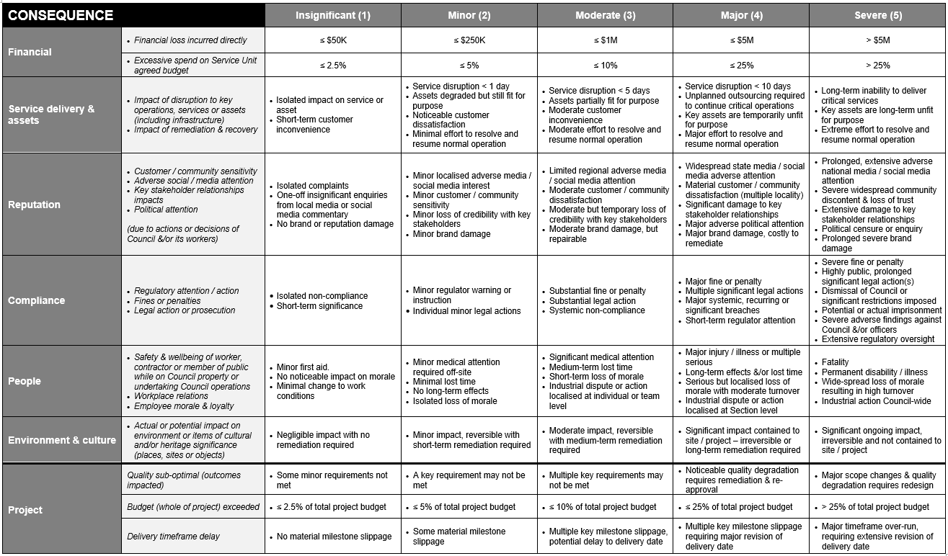

Step 2: Analyse the Likelihood of the Risk Event occurring using the Likelihood Criteria. [Analysis 1 = prior to identified controls being applied (inherent risk)]

LIKELIHOOD Criteria | Descriptor | Frequency or Probability
5 – Almost certain | Clear indication that the risk will materialise. Would be very surprised if it didn’t | Annual | > 90%
4 – Likely | Risk is expected to occur. Would be quite surprised if it didn’t | 1 in 2 year event | 50 – 90%
3 – Possible | Risk is not expected to occur, but would also not be surprised if it did | 1 in 4 year event | 20 – 50%
2 – Unlikely | Risk is not expected to occur, would be quite surprised if it did | 1 in 8 year event | 5 – 20%
1 – Rare | Would be very surprised if the risk occurred | 1 in 20 year event or less | < 5%

Step 3: Plot the Inherent risk rating on the Risk Matrix below.

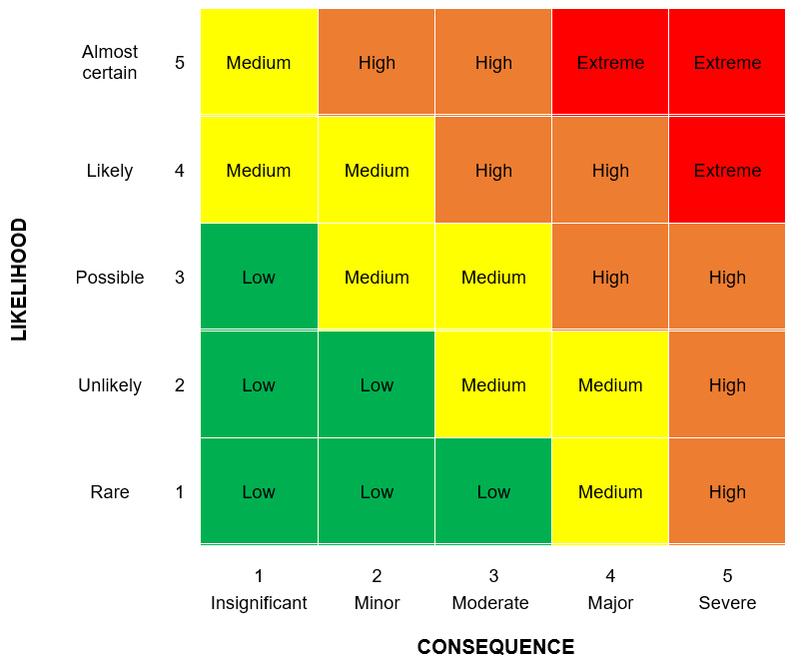

Step 4: Confirm key controls to treat the risk (consider preventative, detective and responsive controls).

Step 5: Repeat steps 1-3 to analyse and assess the Residual Risk (i.e. risk after identified controls are applied).

HIERARCHY OF CONTROLS
Elimination | Remove the risk from the process by eliminating the step in the process – i.e. do not do it. | MOST PREFERABLE
Substitution | Reduce risk by changing processes, materials or equipment to something that does the job more safely
Isolation | Put in place physical preventative mechanisms – i.e. locks, alarms, lights, ventilation, guards & barriers
Engineering Control | Minimise the risk by engineering means – i.e. use a mechanical lifting device rather than manual handling techniques
Administrative Control | Develop and implement work procedures – i.e. Safe Operating Procedures, training, direction, supervision, job rotation, consultation
Personal Protective Equipment | Accept the initial hazards and protect personnel by using personal protective equipment to reduce the risk – i.e. safety glasses, ear muffs | LEAST PREFERABLE

Residual Risk Rating | Preferred Risk Treatment Options
Extreme | Preferred treatment options: AVOID  - Cease activity, process or task until further directed.  - Requires immediate escalation and active management through additional and effective treatment measures to reduce risk before proceeding.  - Detailed planning required in consultation with relevant Group Manager (and/or General Manager) to prepare a risk management plan.  - For safety risks, a Safe Work Method Statement (SWMS) must be approved by the Group Manager (and/or General Manager).
High | Preferred treatment options: AVOID, SHARE, REDUCE  - Subject to discussions with Section Manager (and/or Group Manager), consider ceasing activity, process or task temporarily to explore alternative options or review risk treatment strategies to enhance adequacy and effectiveness.  - For safety risks, a Safe Work Method Statement (SWMS) must be approved by the Section Manager (and/or Group Manager).  - Consider implementation of additional or improved controls to reduce risk to ALARP.  - Continue to monitor control effectiveness.
Medium | Preferred treatment options: REDUCE, ACCEPT  - Subject to discussions with Coordinator or Supervisor (and/or Section Manager), review risk treatment strategies to determine their adequacy and effectiveness.  - Consider implementation of additional or improved controls to reduce risk to ALARP.  - Continue to monitor control effectiveness.
Low | Preferred treatment options: ACCEPT  - Manage by existing approved procedures and work practices,  - Continue to monitor control effectiveness.

COMPILATION OF SWMS
STEP | Number each discrete step in the task in sequence – e.g., 1, 2, etc.
ACTIVITY | Briefly describe the activity to be carried out in each step.
HAZARDS | Identify what in each activity could cause harm to a person, the job, materials, or the environment.
RISK (1) | The degree of risk posed by the hazard. (Use Risk Matrix to determine risk ranking before controls implemented).
CONTROL MEASURES AND ACTIONS REQUIRED | What precautions or control measures must be taken to control the risk?
RISK (2) | The degree of risk following implementation of risk controls (Use Risk Matrix to determine ranking of residual risk).
PERSON RESPONSIBLE | The name or the position of the person responsible for the implementation of the risk controls.

Version Control
Version | Date | Author | Details
1.0 | 10/11/2010 | WHS Manager | First Release - New document
2.0 | 9/3/2012 | WHS Manager | Document reviewed March 2012 due to the new WHS Legislation. All reference to OHS was changed to WHS and The cost associated with controlling the risk must also be considered, including whether the cost is grossly disproportionate to the risk was inserted on page 4
3.0 | 25/06/2012 | WHS Manager | Risk matrix replaced with 5 x 5 matrix and changes were made to document following a review based on WorkCover's recommendations.
4.0 | 13/02/2014 | WHS Manager | Put into new format
5.0 | 10/02/2015 | WHS Manager | Updated Risk Matrix Inserted
6.0 | 6/03/2015 | WHS Manager | Added Compilation of SWMS
7.0 | 3/06/2015 | WHS Manager | Updated to incorporate Brand Identity Style Guide v1.0
8.0 | 08/07/2016 | WHS Manager | Inserted updated Risk Matrix
9.0 | 01/03/2018 | Corporate Risk | Updated following a review of the Integrated Risk Management Framework

