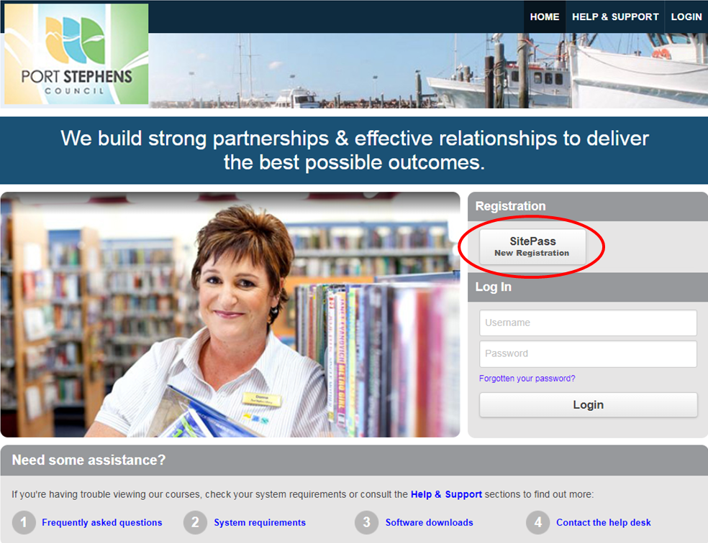

SitePass is the Contractor Management System that Port Stephens Council uses to:

- Register contractor's business and employee details
- Verify your insurances
- Induct contractors and issue induction cards
- Verify work health, safety and environmental documents
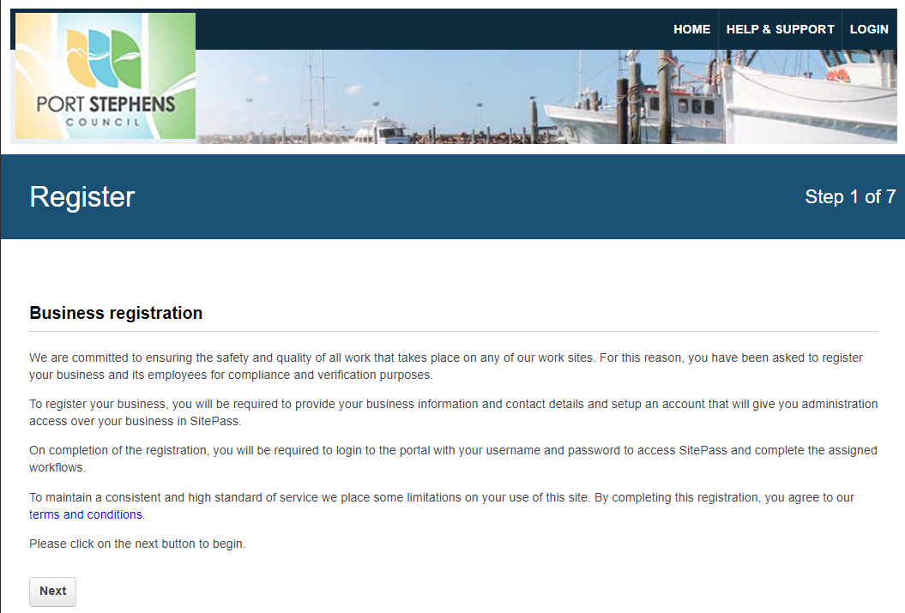

Go to: https://psc.kineoportal.com.au

Click on the SitePass New Registration button to register.

There are 7 steps to the registration process.

You will need to provide business details such as:
- Business Number (e.g. ABN, Company Number)
- Trading Name
- Legal Business Name
- Business Structure
- Country
- Business Address

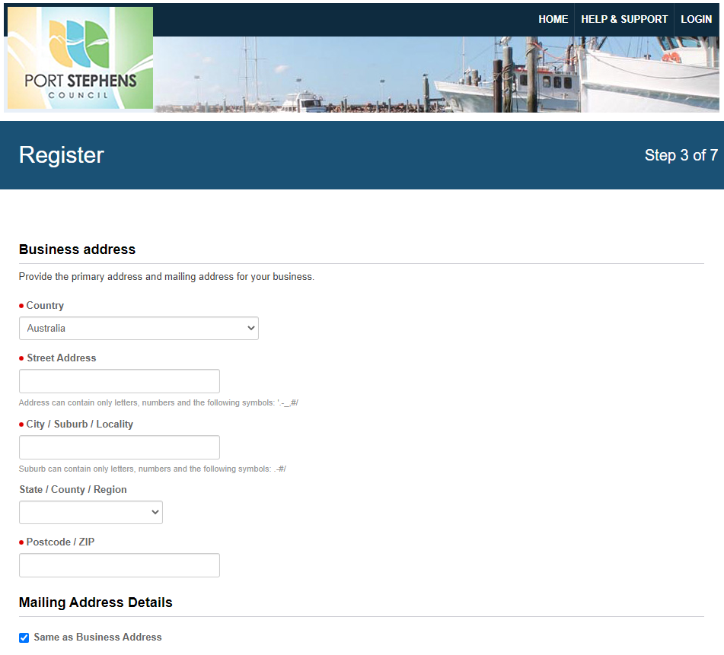

You will be also be required to choose a Business Username and Password for your PSC SitePass account.

As you progress through the self-registration you will be presented with a form to create a SitePass account as shown below, Register your Business.

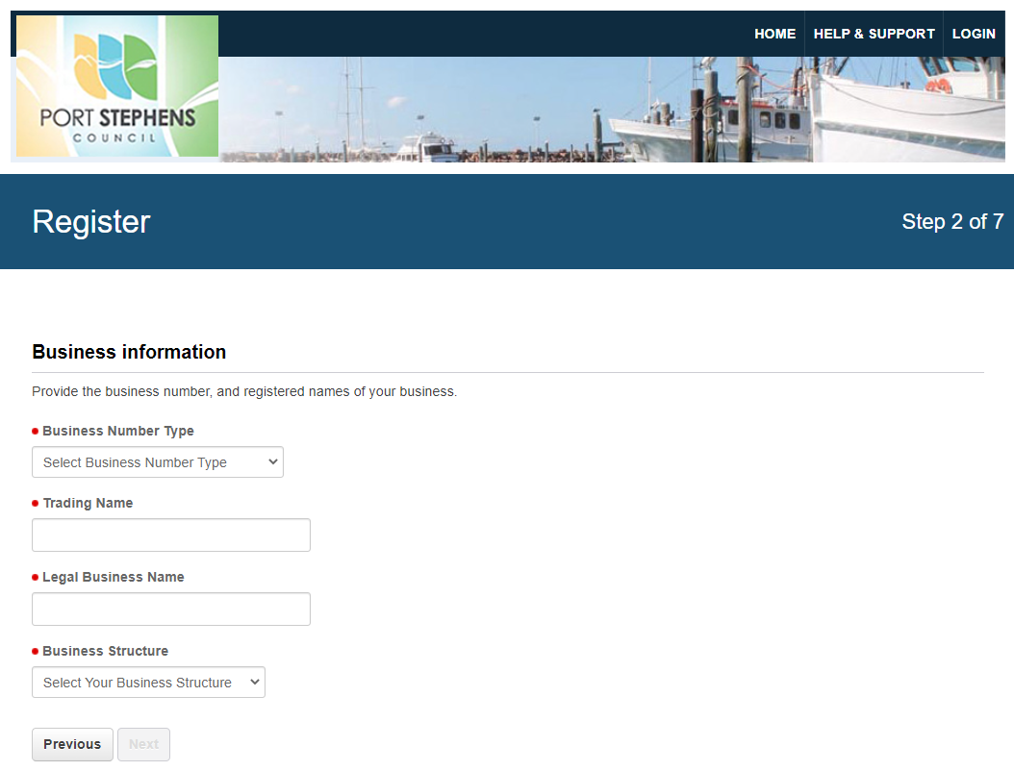

*use all capital letters when entering your business details.

Select PSC Coordinator group and click Add

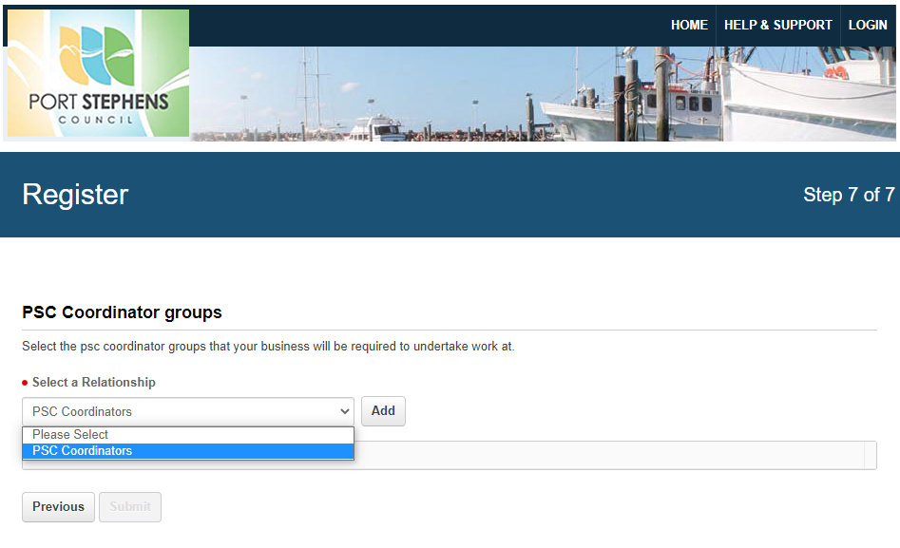

Provide Business Administrator Details:
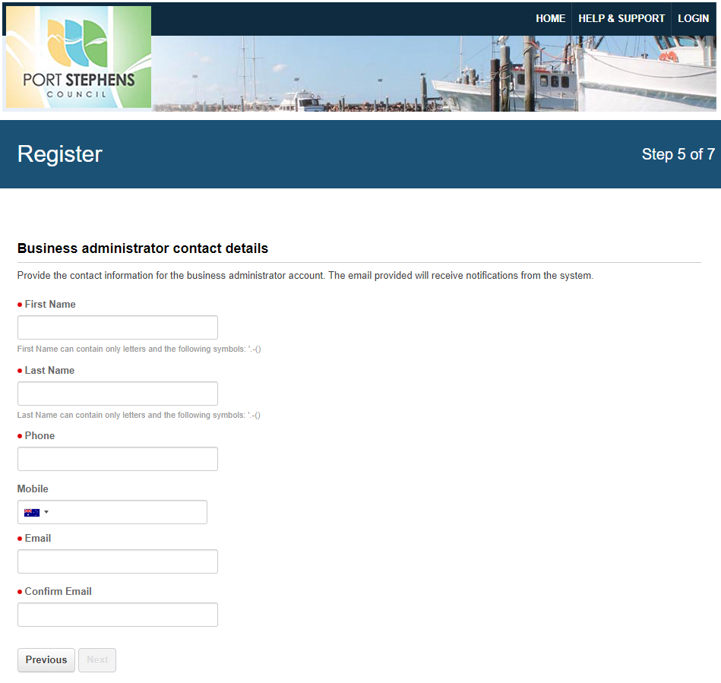
Select Business Category:
E.g. Civil Works & Maintenance, Consultants, Building Maintenance, Waste Management
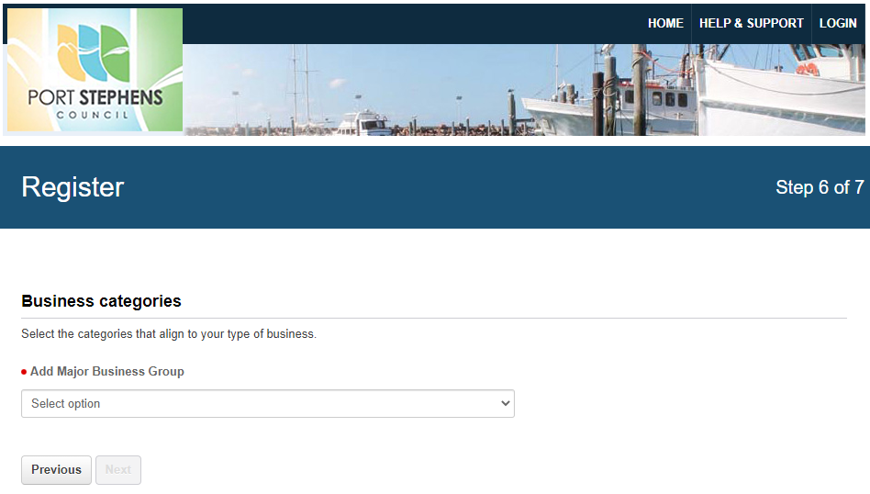

Provide Business Administrator Details:
Select Business Category:
E.g. Civil Works & Maintenance, Consultants, Building Maintenance, Waste Management
To complete the initial registration of your business you will be required to enter an authorisation code. This authorisation code will be sent to the email address you provided.

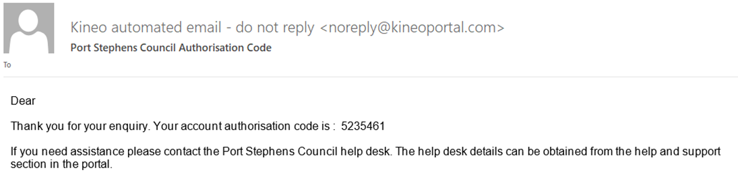
Example of verification email
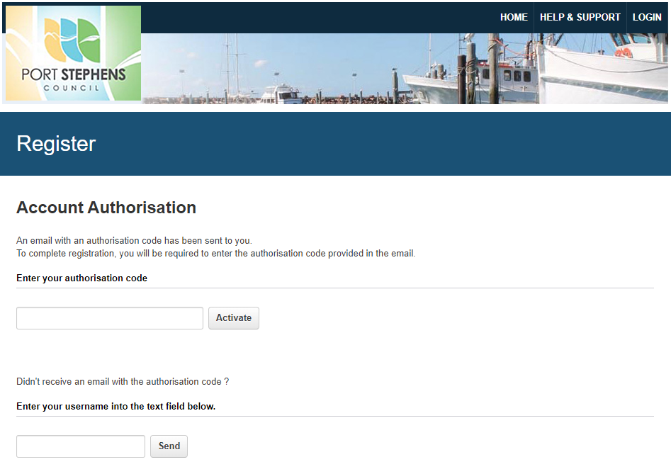
Once you have entered the authoristation code, you can log into the portal with your username and password to access the PSC SitePass Contractor Management System.

ENTERING BUSINESS REQUIRED INFORMATION
You can now start entering your information into each of the sections by clicking on each heading on the left hand side of the page.
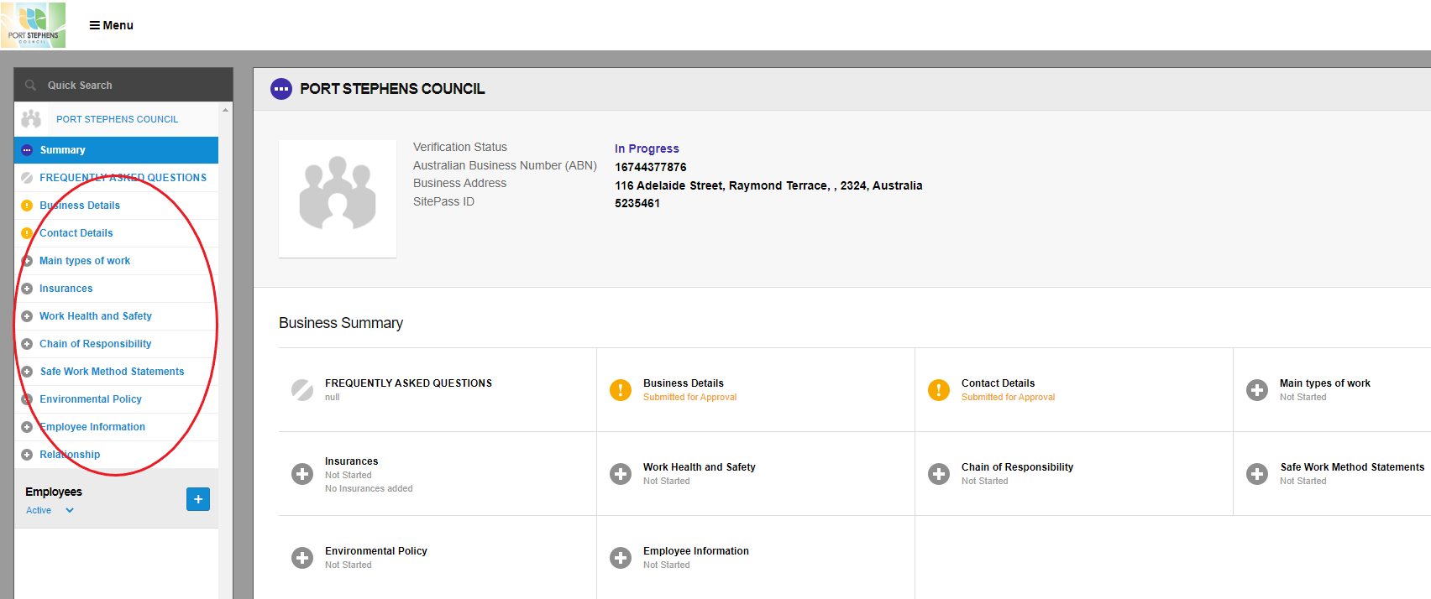

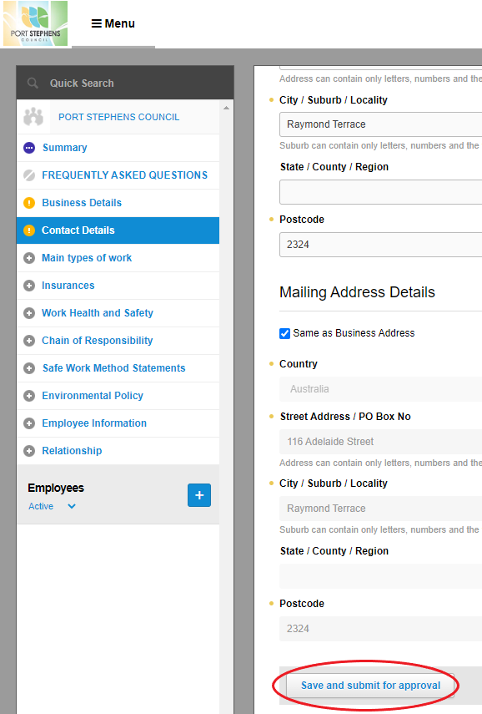

Once you have completed each section,
click on the 'Save and Submit for Approval' button
at the bottom of the page.

INSURANCE REQUIREMENTS:

**NOTE** It is important when you are submitting your insurances that you provide the correct information.
If the correct information is not provided it will delay your registration being approved!

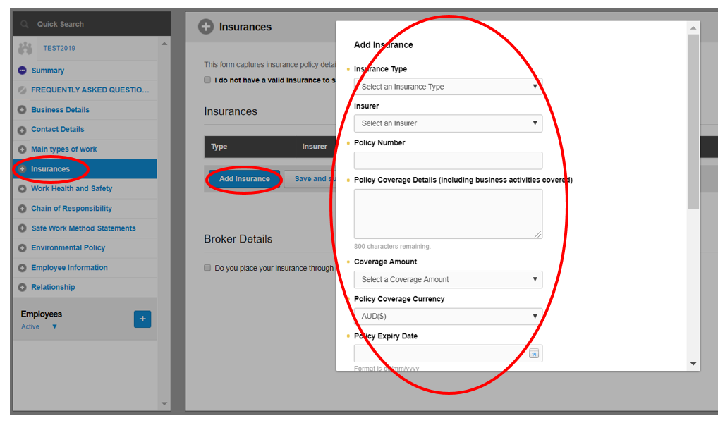
WHAT TYPES OF INSURANCES ARE REQUIRED?

- PUBLIC LIABILITY (min $20million) – required from all businesses
- PROFESSIONAL INDEMNITY (min $10million) – required if providing advice or training
- WORKERS COMPENSATION – required (except Sole Traders)
- MOTOR VEHICLE – required for any vehicle coming onsite

Plus any other relevant insurances particular to the work you do i.e.
CONTRACT, INDUSTRIAL SPECIAL RISK OR PLANT, MARINE LIABILITY etc.

WHAT INSURANCE DOCUMENTATION IS REQUIRED?

- PUBLIC LIABILITY – the full Policy Schedule is required
- PROFESSIONAL INDEMNITY – the full Policy Schedule is required
- WORKERS COMPENSATION – Certificate of Currency is accepted
- MOTOR VEHICLE – Certificate of Currency is accepted for single vehicles,
otherwise for Fleet policies the full Policy Schedule is required.

WHAT IS A POLICY SCHEDULE - this has more detail than a Certificate of Currency, it is sometimes provided with your invoice renewal, if you are supplying it with an invoice please also provide a Certificate of Currency.

WHY A CERTIFICATE OF CURRENCY (by itself) IS NOT ACCEPTED IN MOST CASES
The Certificate of Currency only gives very basic detail, it does not tell us what your business is actually insured to do. It does not detail the business activities, nor does it list any exclusions or endorsements of the policy, this is why we request the full Policy Schedule or alternatively a modified Certificate of Currency which includes this level of detail.

If further information is required you can click on the History button on the top right hand side and scroll through the list to find the relevant history log.

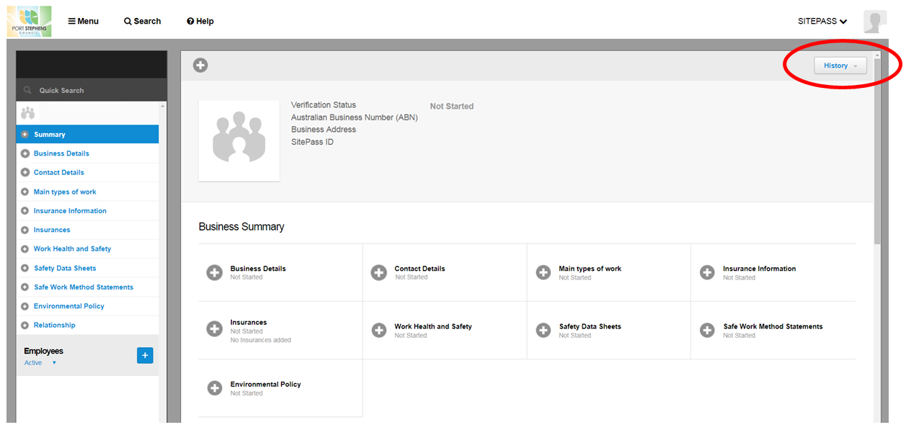

EXEMPTIONS:
Businesses that hold any of the following accreditations, providing this accreditation covers the services they are providing to Council:
- ISO 9001:2008/2015 Quality Management System;
- ASNZS 4801 OHS Standard Certification;
- OHSAS 18001;
- ISO 45001 – The New Health and Safety Management Standard; or
- ISO 14001 (Environment)
or are:
- a Federal or State Government department;
- a Government run institution (e.g. university, TAFE); or
- a Registered Training Organisation
are not required to provide SWMS, SDS's, employee details, however proof of current certification will be required to be uploaded into SitePass under the Work Health and Safety section.
ALL CONTRACTORS, irrespective of the exemptions noted above, are required to register their organisation's details in SitePass, which includes proof of relevant insurances, and acknowledgement that all relevant aspects of the Contractor's obligations under the Chain of Responsibility (CoR) requirements of the Heavy Vehicle National Law (NSW) legislation, as amended, are considered in the supply and delivery of goods.

EMPLOYEES:
When you get to the employee section click on the blue cross to enter each employee's details and upload their profile photo.

Once you have added and created the employee, the system will send the employee an email with their login details advising them to login and to complete their:

- Your Role – a brief description of their role undertaken
- Licences – applicable to job (e.g. Drivers Licence, White Card, Pesticides, Working from Heights etc.)
- Induction Training

Each employee will be required to complete an online Induction Training to perform work for PSC.

The employee will need to be logged in as themselves to be able to access and complete their online induction. Click on 'Induction Training' on the left hand side of the screen and click to Launch Course.

The induction takes 30-40 mins to complete and requires a minimum score of 75% to be approved.
After completion of the course, it will be automatically submitted for approval.

Any employee or sub-contractor is required to be registered and approved in PSC SitePass before coming onsite.
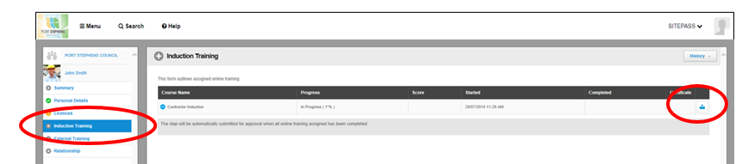

All information will now be verified by Port Stephens Council's Corporate Risk Management Team. If additional information or clarification is required we will send you an email via SitePass requesting further information.

Your business will only be endorsed if all of your details have been uploaded into SitePass and verified to ensure they meet the requirements for the work being carried out with Port Stephens Council.

Your Business will only be fully approved once all sections are green ticked, and the Verification Status will say Approved.

Following verification, each employee will receive their own individual induction card, which they will need to have with them when on-site.
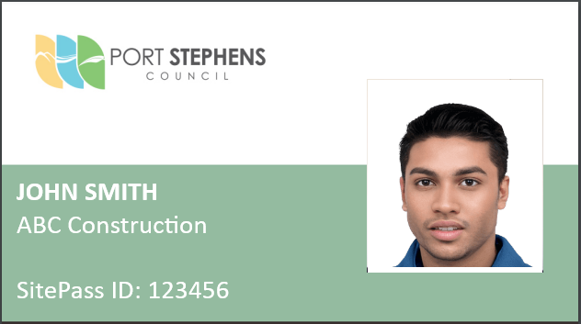
* QR Codes can be scanned with the camera of any smart phone or tablet

You can log out at any time by selecting Logout from the Menu.
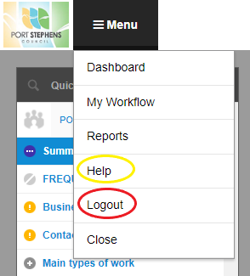

If you have any questions regarding Work, Health and Safety at Port Stephens Council,
please contact Nicole Le Grange on (02) 4988 0158 or nicole.legrange@portstephens.nsw.gov.au.

If you require further information or want to find out more about SitePass, click on the Help dropdown option.

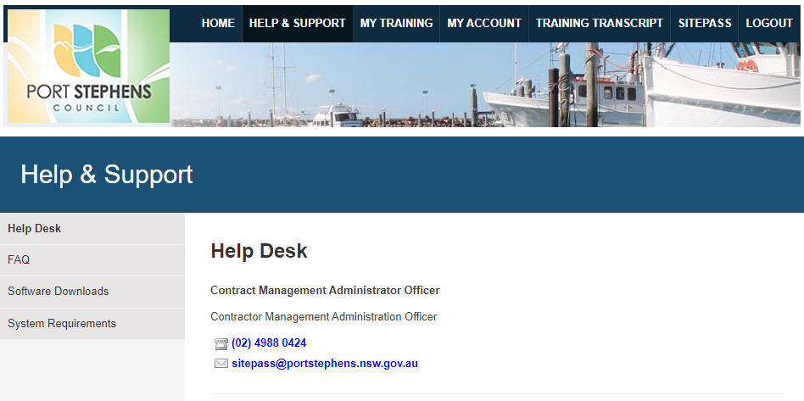

For help and support please contact:

Contractor Management Administration Officer

Telephone: 02 4988 0424

Facsimile: 02 4987 3612

Email: sitepass@portstephens.nsw.gov.au

Web: www.portstephens.nsw.gov.au

Address: Administration Building, 116 Adelaide Street, Raymond Terrace NSW 2324

Postal: PO Box 42, Raymond Terrace NSW 2324

SITEPASS: https://psc.kineoportal.com.au

